**Unveiling Market Insights: Analysing Spending Behaviour and Identifying Opportunities for Growth**

Define Problem / Problem Understanding

* 1. **Specify the business problem**

Refer Project Description

**Requirements**

1. Analyzing spending behavior and identifying opportunities for growth can provide crucial market insights for businesses looking to optimize their strategies and increase market share.
2. Pricing Optimization: Analyze the relationship between pricing and spending behavior to identify pricing strategies that maximize revenue while maintaining customer satisfaction.
3. Purchase Patterns: Analyze the frequency and timing of customer purchases to identify seasonal trends or patterns that can guide inventory management and marketing campaigns.
4. Competitor Analysis: Compare your spending behavior data with competitors to understand your market position, pricing strategies, and areas where you can gain a competitive advantage.
5. For this Created KPI’s and interactive Visualizations and Dashboard and story Board to bring clean and deep understanding of the data.

**Literature Survey**

1. A literature survey is a method of researching existing literature and studies related to a specific topic. In the context of Measuring Success in Talent Management, a literature survey would involve reviewing studies and articles that have been published on the topic of Wholesaler a customer. The literature survey would include sources such as academic journals, industry reports, and online articles. It would aim to identify key performance indicators (KPIs) and metrics that are commonly used to measure wholesaler customers. The literature survey would also explore any existing research on The Tableau HR

**Business Impact**

It shows the information about the data and shows the weak regions and channels and helps to improve the weakness and helps where to improve. By this the wholesaler makes plans to transport the goods and where to transport more goods. And what type of goods are selling more in which region and channel.



**Social Impact:**

● Personalization and Targeted Marketing: With insights from spending behavior analysis, businesses can personalize marketing efforts and promotions. This targeted marketing approach reduces unnecessary advertising noise and enhances the relevance of promotional messages for consumers.

● Economic Growth and Job Creation: As businesses identify growth opportunities and optimize their strategies, they often experience increased revenue and expansion. This can lead to economic growth and job creation, benefiting local communities and contributing to the overall prosperity.

**Business Impact**

It shows the information about the data and shows the weak regions and channels and helps to improve the weakness and helps where to improve. By this the wholesaler makes plans to transport the goods and where to transport more goods. And what type of goods are selling more in which region and channel

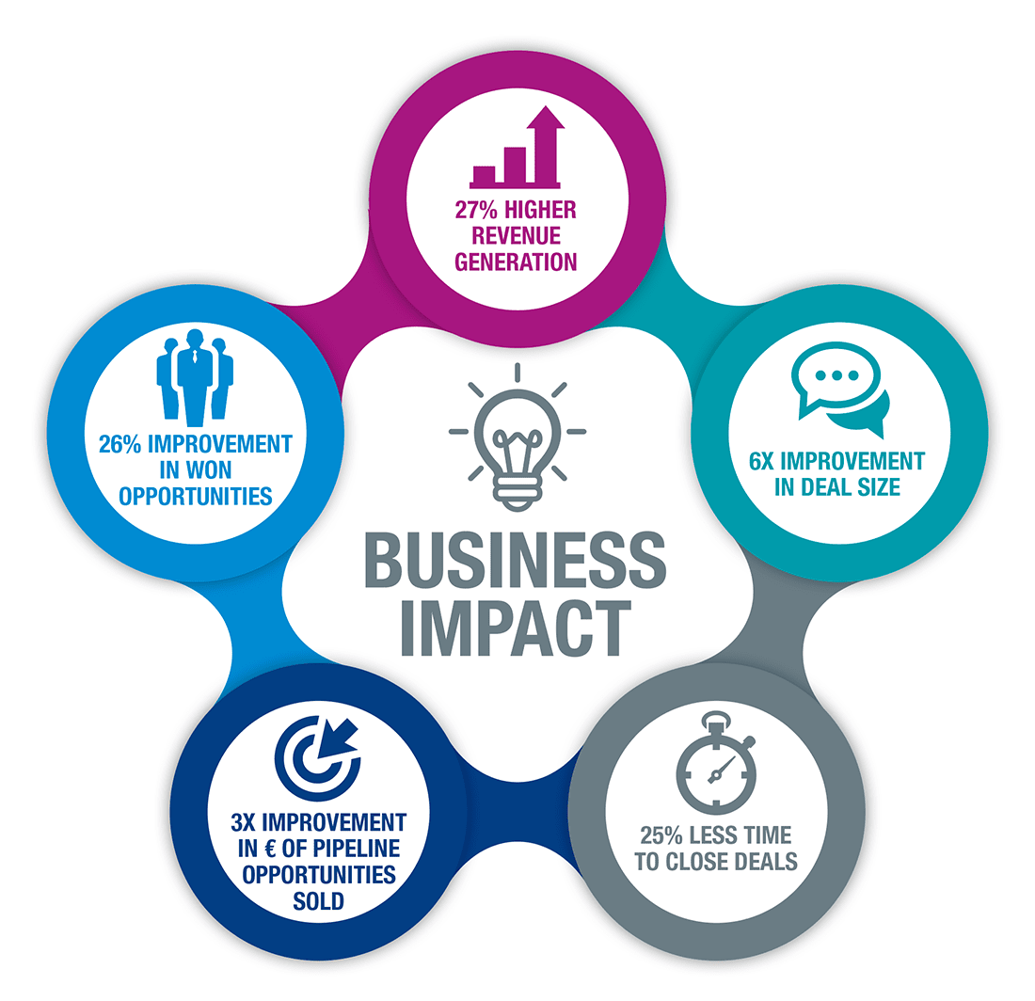

**Business Impact:**

**● Revenue Growth**: Leveraging market insights to identify growth opportunities can lead to increased sales and revenue for businesses. Understanding customer preferences and optimizing product offerings can attract more customers and improve customer retention.

**● Cost Optimization:** Data-driven decision-making allows businesses to allocate resources more efficiently. By identifying underperforming products or unprofitable channels, businesses can optimize costs and improve their bottom line.

**Collect the dataset *& Extraction from Database***

Data collection is the process of gathering and measuring information on variables of interest, in and established systematic fashion that enables one to answer stated research questions, test hypotheses, and evaluate outcomes and generate insights from the data.

**Collect the dataset**

Please use the link to download the dataset: Link

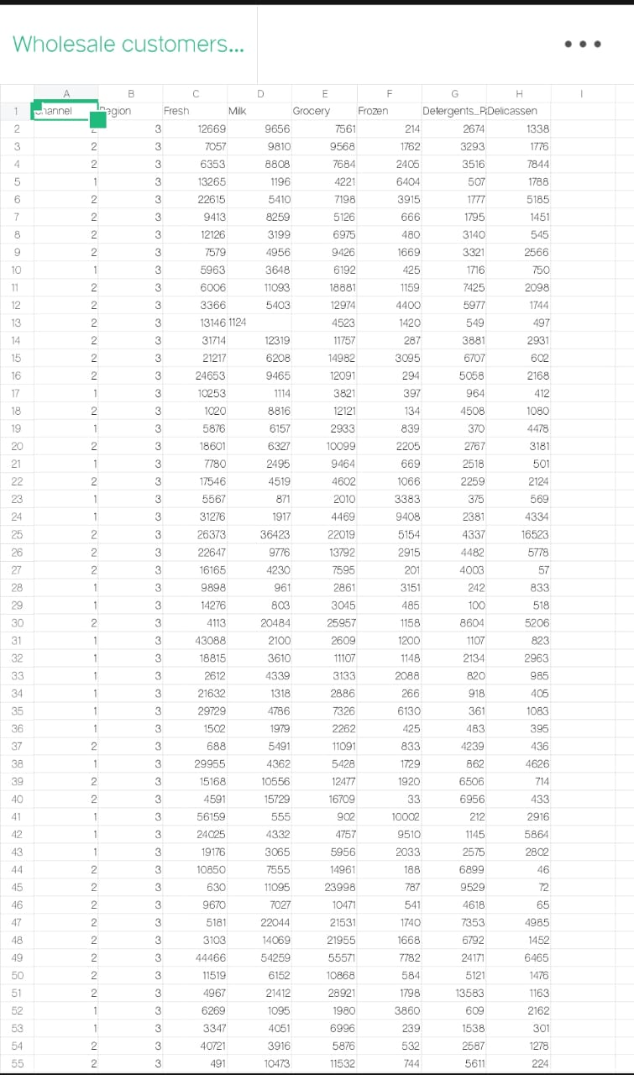

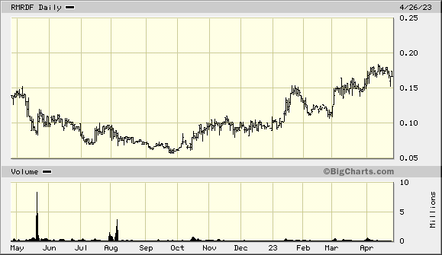

**Activity 1.1: Understand the data**

Data contains all the meta information regarding the columns described in the CSV file. we have provided CSV file:

Wholesaler Customer Data.Csv

**Column Description**

**Region:** It is dimension Data in Wholesaler data.

**Channel:** It is also a Dimension data.

**Fresh:** It is a product in data and it measures the selling quantity of fresh.

**Milk: It is measured and shows the quantity of selling Milk.**

**Grocery:** combination of products used to Prepare food comes under measure.

**Frozen:** food that has been subjected to rapid freezing and it is measured.

**Detergent paper:** It is also a measure in the wholesaler customer data.

**Delicatessen:** It is also one of the products sold by the wholesaler.

**Data Preparation**

**Activity 1: Prepare the Data for Visualization**

Data modules are containers that describe data and rules for combining and shaping data to prepare it for analysis and visualization in Tableau. Data module sources. Data modules can be based on data servers, packages, uploaded files, data sets, and other data modules.

**Data Visualization**

Data visualization is the process of creating graphical representations of data in order to help people understand and explore the information. The goal of data visualization is to make complex data sets more accessible, intuitive, and easier to interpret. By using visual elements such as charts, graphs, and maps, data visualizations can help people quickly identify patterns, trends, and outliers in the data.

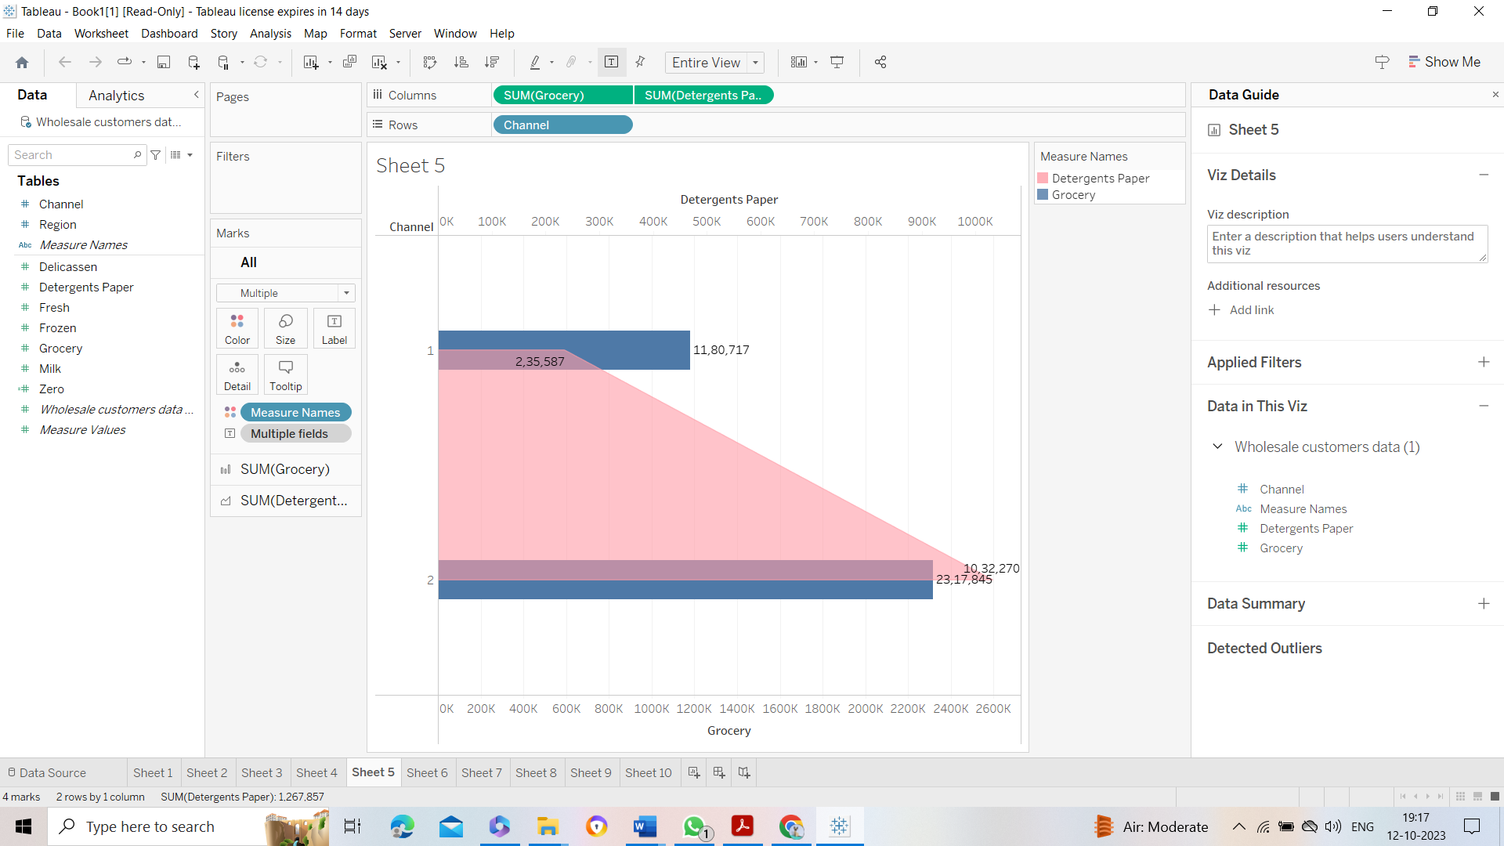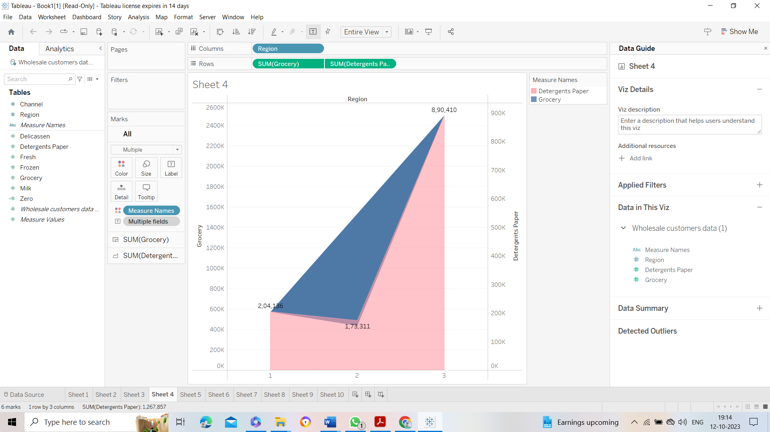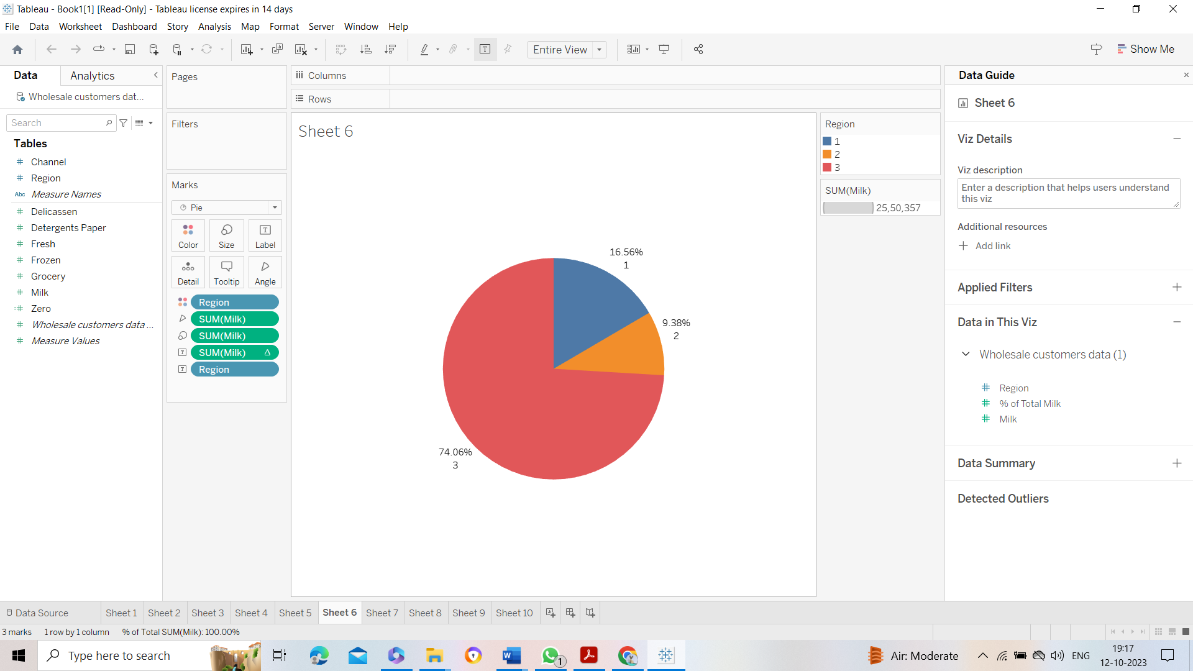

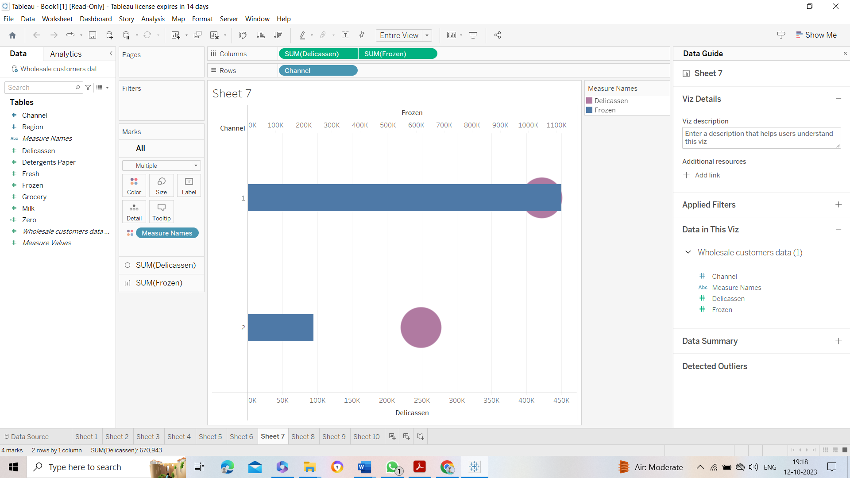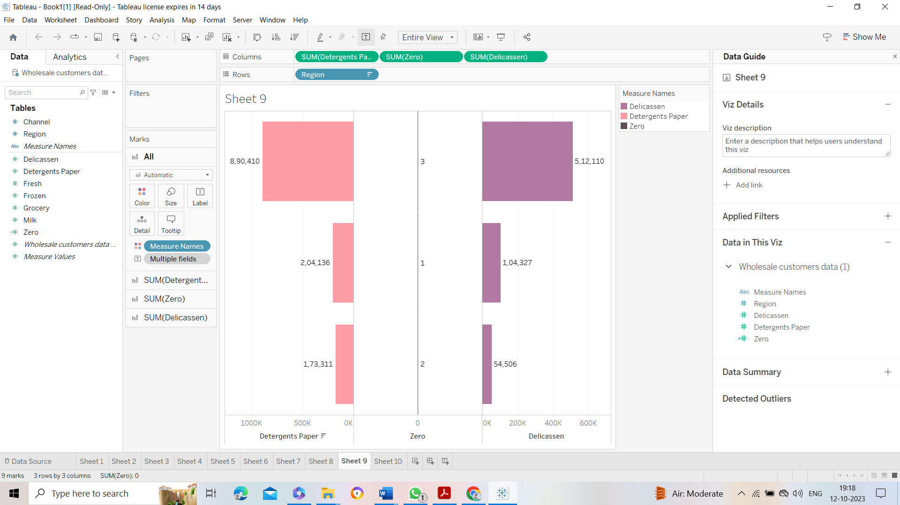

**Dashboard**

A dashboard is a graphical user interface (GUI) that displays information and data in an organized, easy-to-read format. Dashboards are often used to provide real-time monitoring and analysis of data, and are typically designed for a specific purpose or use case. Dashboards can be used in a variety of settings, such as business, finance, manufacturing, healthcare, and many other industries. They can be used to track key performance indicators (KPIs), monitor performance metrics, and display data in the form of charts, graphs, and tables.

**Milestone 6: Story**

A data story is a way of presenting data and analysis in a narrative format, with the goal of making the information more engaging and easier to understand. A data story typically includes a clear introduction that sets the stage and explains the context for the data, a body that presents the data and analysis in a logical and systematic way, and a conclusion that summarizes the key findings and highlights their implications. Data stories can be told using a variety of mediums, such as reports, presentations, interactive visualizations, and videos



**Milestone 9: Project Demonstration & Documentation**

Below mentioned deliverables to be submitted along with other deliverables

**Activity 1:- Record explanation Video for project end to end solution**

**Activity 2:- Project Documentation-Step by step project development procedure**